Instructions for compiling ISOmodel using Visual Studio 2022 / VS 2022 community edition

If you plan to work from the publicly available, open source, ISOmodel git repository and keep your changes/additions open source, the terms of use allow use of VS 2022 community edition even if you are a commercial business or enterprise. If you are a commercial company and plan on keeping those changes within your company or releasing in closed source software, you cannot use VS 2022 community edition and must have a licensed version VS 2022 Pro.

In the setup process it’s best to install CMake first so that the Visual Studio environment can find CMake during its own install.

Install CMake >=3.12.3
https://github.com/Kitware/CMake/releases/download/v4.0.1/cmake-4.0.1-windows-x86_64.msi
https://cmake.org/download/
Choose the latest version of CMAKE for windows X64 installer

Install with the option “Add CMake to the PATH environment variable” checked.
This will prompt for admin login

Download VS 2022/ VS 2022 Community Edition and begin installing
Select Desktop development with C++ and use default settings. You might want to uncheck GitHub Copilot if you don’t want more Copilot stuff. Here is what my install looks like with GitHub Copilot unchecked.

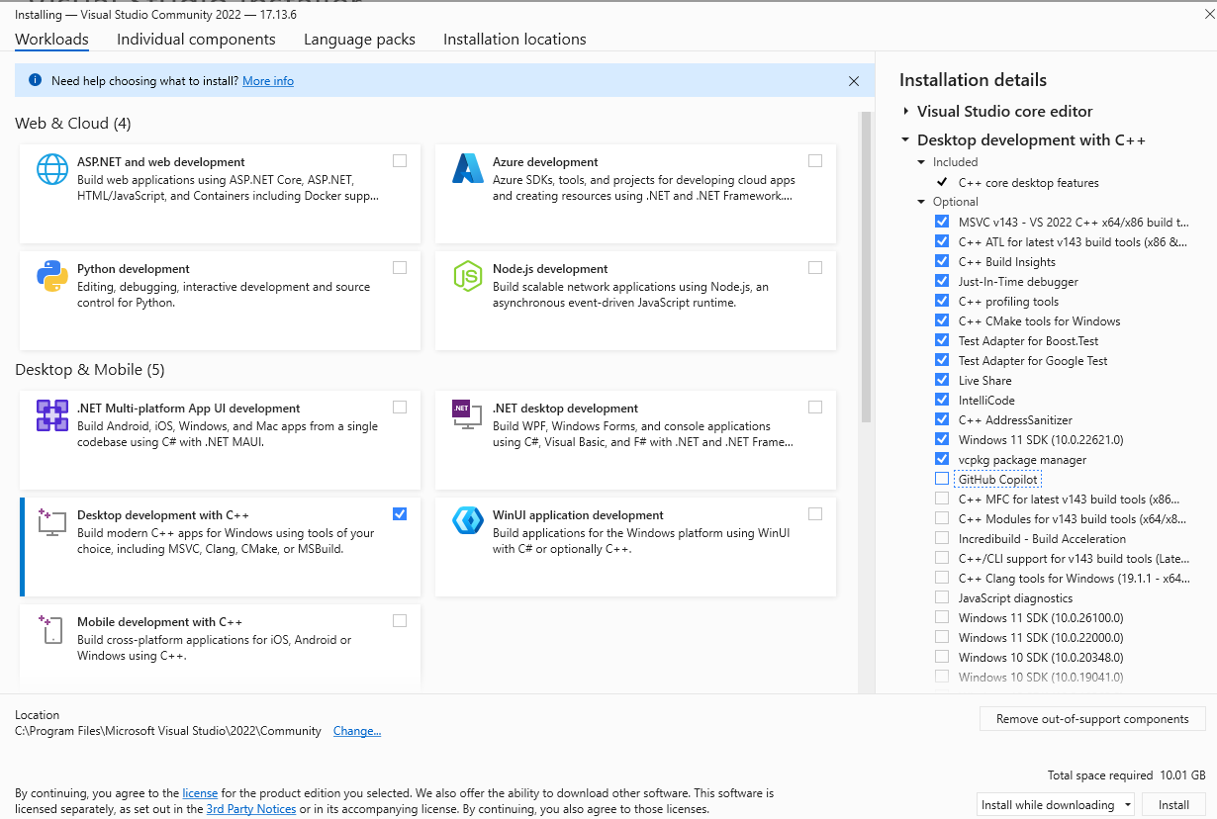

Install Boost =1.88 prebuilt binaries for msvc 14.3-64
Boost 1.89 is currently available, but the code is not able to compile with Boost 1.89 so for now use 1.88
(Visual Studio 2022 Version > 17.10 is actually msvc 14.4-64 but things have been set to work with the newer updates to VS 2022)

https://archives.boost.io/release/1.88.0/binaries/boost_1_88_0-msvc-14.3-64.exe

You likely will get a warning from Microsoft that the software is suspect If you downloaded it direct from archives.boost.io it should be safe to override the warning and install.

Install to a simple easy to find directory like C:\local\boost_1_88_0

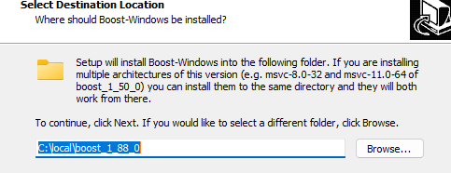

Creating Visual Studio Project Files

First we need to create the .sln files
Go to isomodel directory root (e.g. c:\git\isomodel\isomodel\) and make a binary directory

cd C:\git\idomodel\isomodel
mkdir bin
cd bin

Now, if you are lucky, cmake will autodetect Visual Studio 22 and the Boost libraries.
Try creating the Visual Studio 2022 project files with the command line:

cmake ../src

If all goes well things will run, print some output, a couple warnings but then finally end with the following lines (times will differ on your machine)

-- Configuring done (73.1s)
-- Generating done (1.1s)
-- Build files have been written to: C:/Git/ISOmodel/IsoModel/bin

Here is the full output on my computer
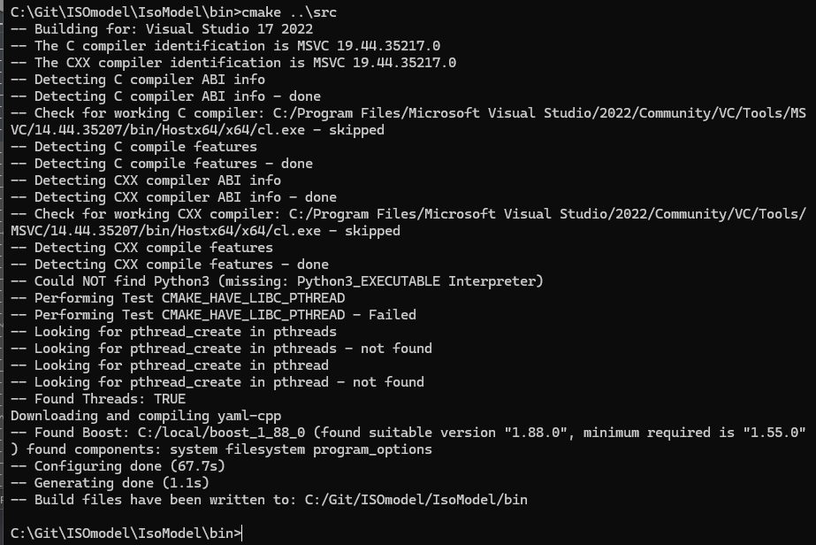

If cmake terminates in an error it is probably not finding the Visual Studio compiler and/or the boost files. If you don’t see a line like:

-- Found Boost: C:/local/boost_1_88_0 (found suitable version "1.88.0", minimum required is "1.55.0") found components: system filesystem program_options

then the boost files were not found and you need to add the following to the cmake command line replacing boost_1_88_0 with your version

cmake ../src -DBoost_LIBRARY_DIR="C:/local/boost_1_88_0/lib64-msvc-14.3" -DBoost_INCLUDE_DIR="C:/local/boost_1_88_0"

If you don’t see something like the following line at the top, then the Visual Studio compiler was not found
-- Building for: Visual Studio 17 2022
And then farther down
-- The C compiler identification is MSVC 19.44.35217.0
-- The CXX compiler identification is MSVC 19.44.35217.0

Add -G "Visual Studio 17 2022" to the cmake command line.

Or you can add both to the command line if necessary

cmake ../src -G "Visual Studio 17 2022" -DBoost_LIBRARY_DIR="C:/local/boost_1_88_0/lib64-msvc-14.3" -DBoost_INCLUDE_DIR="C:/local/boost_1_88_0"

A completed cmake process will have created a CMakeFiles directory and a bunch of other visual studio project files in the bin directory including “isomodel_project.sln”. My directory looks like the following
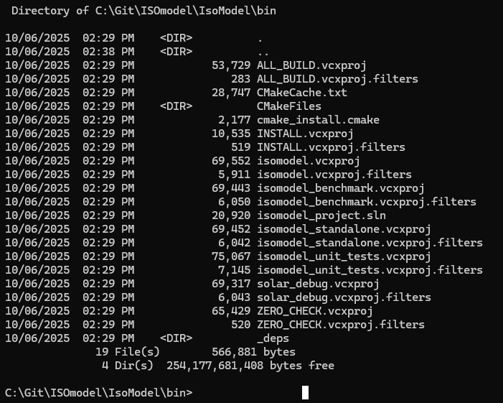

Compiling isomodel using Visual Studio IDE

Load isomodel_project.sln into Visual Studio and change build to Release, x64 and build the entire project

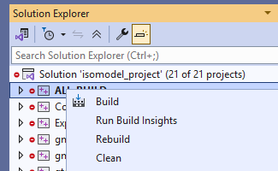

This will compile yaml-cpp, googletest, and the ISOmodel. You should get no warnings/errors when Visual Studio is compiling yaml-cpp and googletest, but will get many warnings when compiling the ISOmodel itself. Hopefully the compiling will occur without error and youll eventually get output like this:

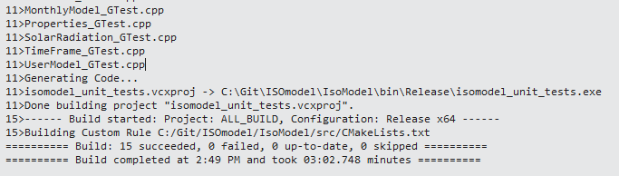

Testing the Build.
Now you need to copy some test data to the directory where the isomodel_standalone.exe is located as the build scripts aren’t copying it (yet). In your terminal get to the isomodel\isomodel\bin directory and give the following commands

cd Release\test_data

..\isomodel_standalone.exe -h -I SmallOffice_v2_ism.yaml

You should get something like the following out
